Green Society Public School
D-
Ratnanagar-7, Sauraha, Chitwan
Annual Examination-2082
Class: Three Time: - 1 hr. F.M.: 25
Sub: Science
Name: Roll No.: Sec.:
________________ ______________ OBT.MARKS:
INVIGILATOR EXAMINER
1) Tick (✓) the correct answer. (3×1=3)
a) What is hydrosphere?
i) area of land ii) area of air iii) area of water
b) Which is non-decomposable waste?
i) Plastic ii) leaves iii) food
c) What is like a machine?
i) Coat ii) Body iii) Jacket
2) Write “T” for true and “F” for false statement. (3×1=3)
a. A fridge is used to keep fruits and vegetables fresh in a large scale. ______
b. Sharpened tools are safe for children to use. ______
c. Harmful insects like clean environment. ______
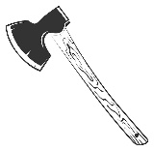

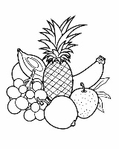
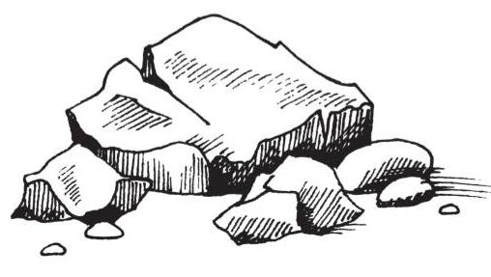
3) Identify the picture. (4×1=4)

4) Match the following. (4×1=4)
a. Atmosphere Diseases
b. Diarrhoea pollution
c. Plastic burning The layer of air
d. Ludo Indoor game

5) Answer these questions. (4×2=8)
a) What is the larger part of the earth’s surface covered with?
________________________________________________________________________
b) Name any 2 local technologies used in Nepal.
________________________________________________________________________
c) What is environment?
________________________________________________________________________
d) Write any 2 examples of junk food.
________________________________ ______________________________
6. Draw a picture of the earth. (3)

The End

